**CONVERSATION ENGINE FOR DEAF AND**

**DUMB PEOPLE**

**Project report**

**Vellore institute of Technology, Bhopal**



Team members

* Ashish Maan
* Devika Srivastava
* Kanchan Joshi
* Akanksha Sharma
* Hemang Maan

**INTRODUCTION:**

* HGRVC (Hand Gesture Recognition and Voice **Conversion**) system localizes and track the hand gestures of the **dumb** and **deaf** people in order to maintain a communication channel with the other people.
* The method gives output in text format that helps to reduce the communication gap between **deaf** & **dumb** people.

**Purpose**

* The only means of communication for **deaf and dumb** people is the **sign language**.
* This **application** helps the **deaf and dumb** person to com with rest of the world using **sign language**.

**LITERATURE SURVEY:**

**EXISTING PROBLEM:**

Different approaches are employed by completely different researchers for recognition of varied hand gestures that were enforced in numerous fields. The total approaches can be divided into 3 broad classes Hand segmentation approaches Feature extraction approaches and Gesture recognition approaches.

**PROPOSED SOLUTION:**

* Sign language is used as a communication medium among deaf and dumb people to convey the message with each other.
* In order to bridge the gap in communication among deaf, dumb community and normal community, lot of research work has been carried out to automate the process of sign language interpretation with the help of image processing and pattern recognition techniques.

**THEORITICAL ANALYSIS:**

**BLOCK DIAGRAM:**

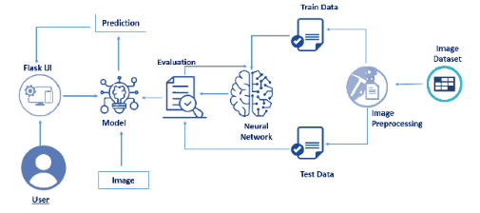

**SOFTWARE DESIGNING:**

To complete this project, you must require the following software, concepts, and packages

1. Anaconda (IDLE / Spyder / PyCharm)(Python 3.7):
2. Python Packages
3. Tensorflow:- This package is used as backend support to Keras
4. Keras:- This package is used for building Neural Network layers
5. OpenCV:- This package is used for image processing
6. Flask:- To build a web application to show output.

**EXPERIMENTAL INVESTIGATIONS:**

Training results:-

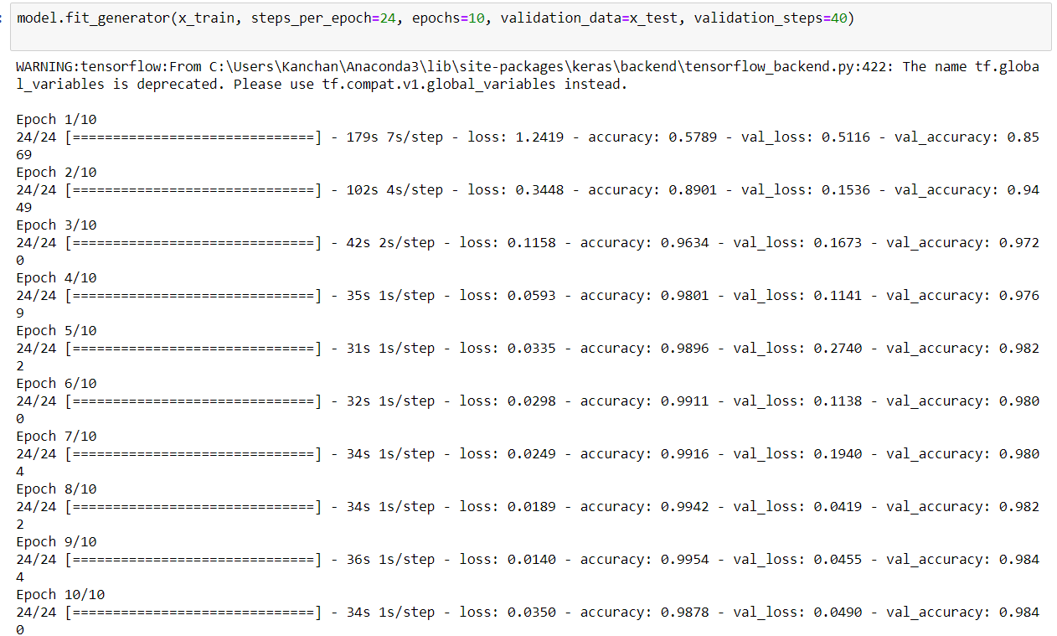

Testing results:-

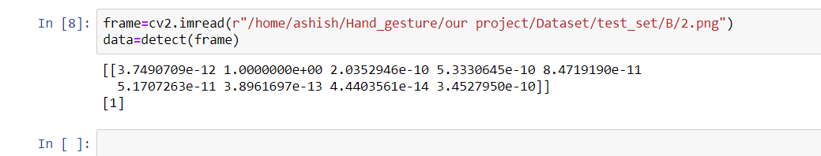

**FLOW CHART**

Understanding data

Data preprocessing

Training

testing

Results

**RESULT:**

This is the final output of our flask application.

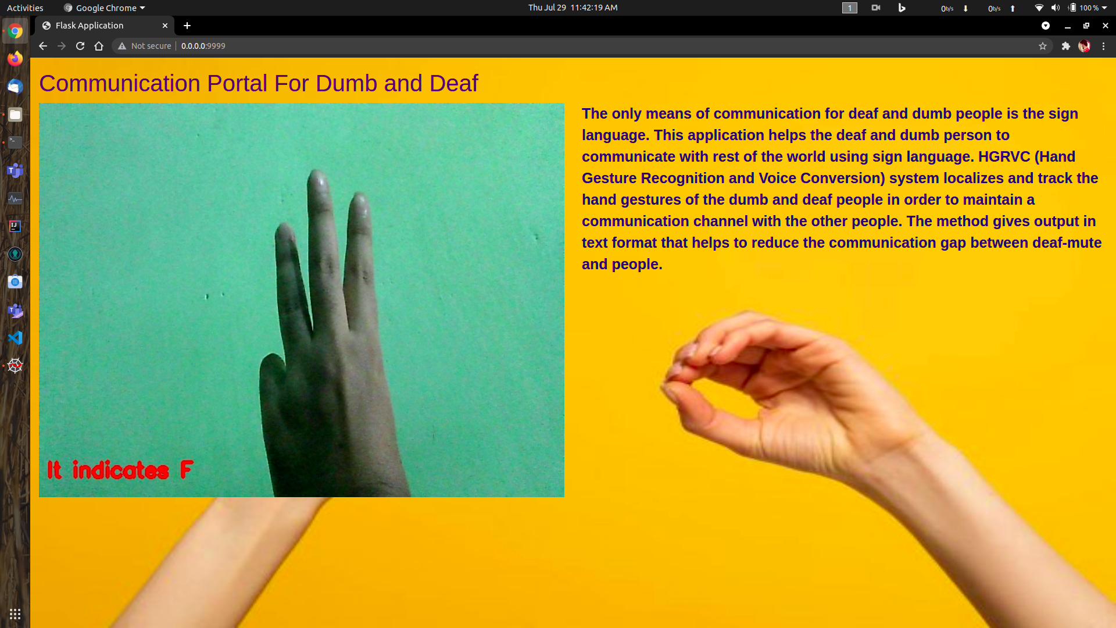

**ADVANTAGES AND DISADVANTAGES:**

**ADVANTAGES:**

It provides an environment for the user to send message through a sign language. It recognizes the hand gestures of sign language through image processing.

Other feature converts the speech spoken into text.

**DISADVANTAGES:**

It has limitations such as it cannot convert text to speech now but it can be upgraded.

**APPLICATIONS:**

* To cater the needs of children who are non-verbal or are having speech problems.
* The app comes to the aid of mute, deaf and other non-verbal users when having a conversation with other people.

**CONCLUSION:**

Using this model we built it will greatly help the deaf and dumb people as it convert sign language into text. It will improve the communication between them.

**FUTURE SCOPE:**

Lot of developments can be made in the application such as:-

* Adding feature like converting text to speech.
* We can also create a mobile app for the same.
* We can add more dataset so efficiency of model will greatly increase.

**BIBLIOGRAPHY:**

* Smartinternz.com
* Stackoverflow.com
* Images from google

**LEARNING EXPERIENCES:**

As a team, we learnt

* How an app is built using flask and integrate with html page.
* How to train a model on IBM Watson.
* How train and test is done using jupyter notebook.
* Working of Spyder.